Exp 01:Student Attendence Tracker

Aim : To develop a cloud-based application to track and manage student attendance.
Software Required
- Zoho Creator
- Web Browser
- Internet Connection
Procedure
- Create a new application in Zoho Creator
- Create Users form (Student details)
- Create Attendance form (Date, Status, Student)
- Link student using lookup field
- Create report to view attendance
- Publish the application
Output:
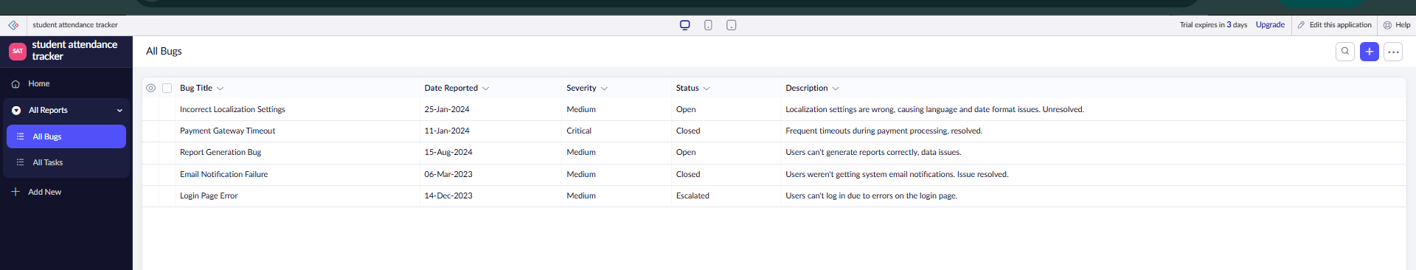
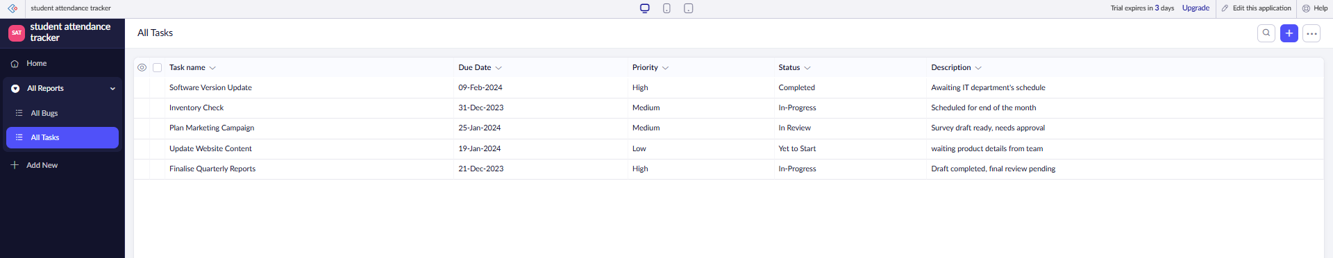
Result
A SaaS-based attendance tracker is created to manage student attendance online.

Exp 02: Flight Reservation System

Aim: To develop a cloud-based system for flight booking and reservation.
Software Required
- Zoho Creator
- Internet Browser
Procedure
- Create application in Zoho Creator
- Create Users form (Passenger details)
- Create Flights form (Flight details)
- Add booking field (Passenger lookup)
- Create reservation report
- Publish the application
Output:
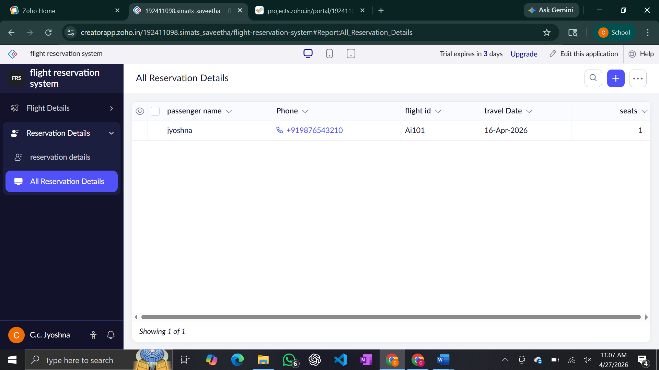
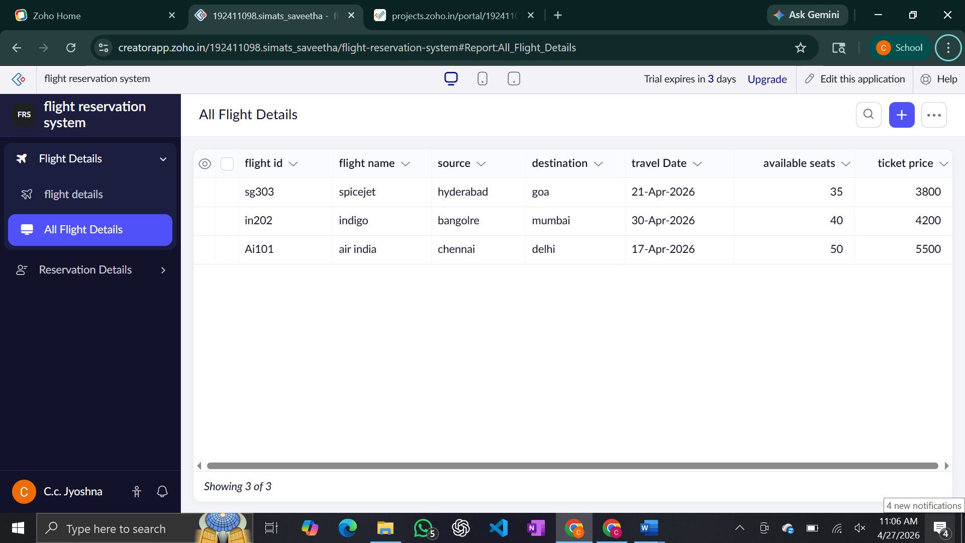
Result: A SaaS-based flight reservation system is developed for booking flights online

Exp 03: Chennai property buying

Aim: To develop a SaaS application for managing property buying and rental in Chennai.
Software Required
- Zoho Creator
- Internet
Procedure
- Create app in Zoho Creator
- Create Users form (Buyer/Owner)
- Create Properties form (Location, price, type)
- Add interested buyer field (lookup)
- Create property report
- Publish application
Output: 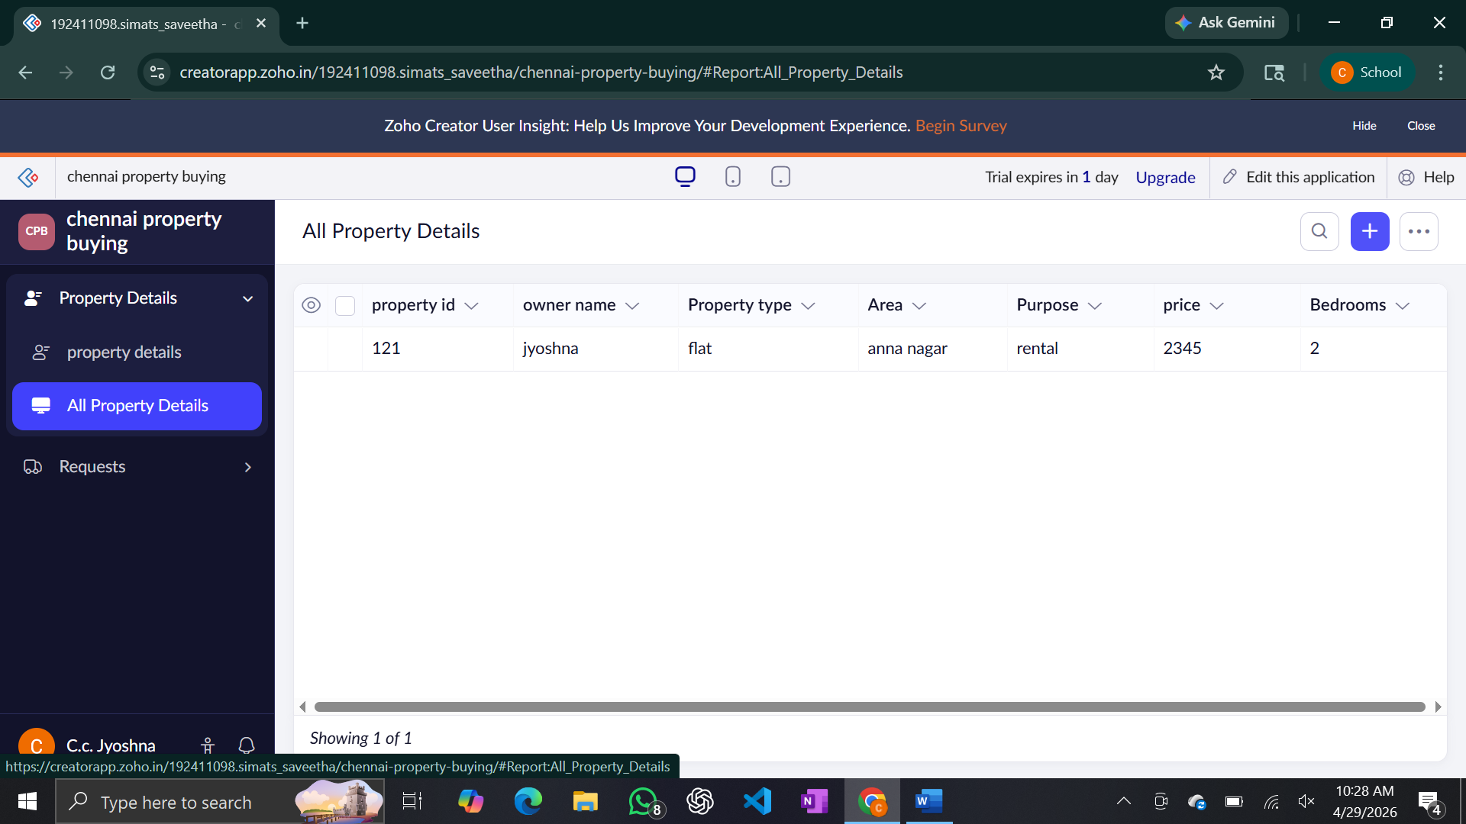
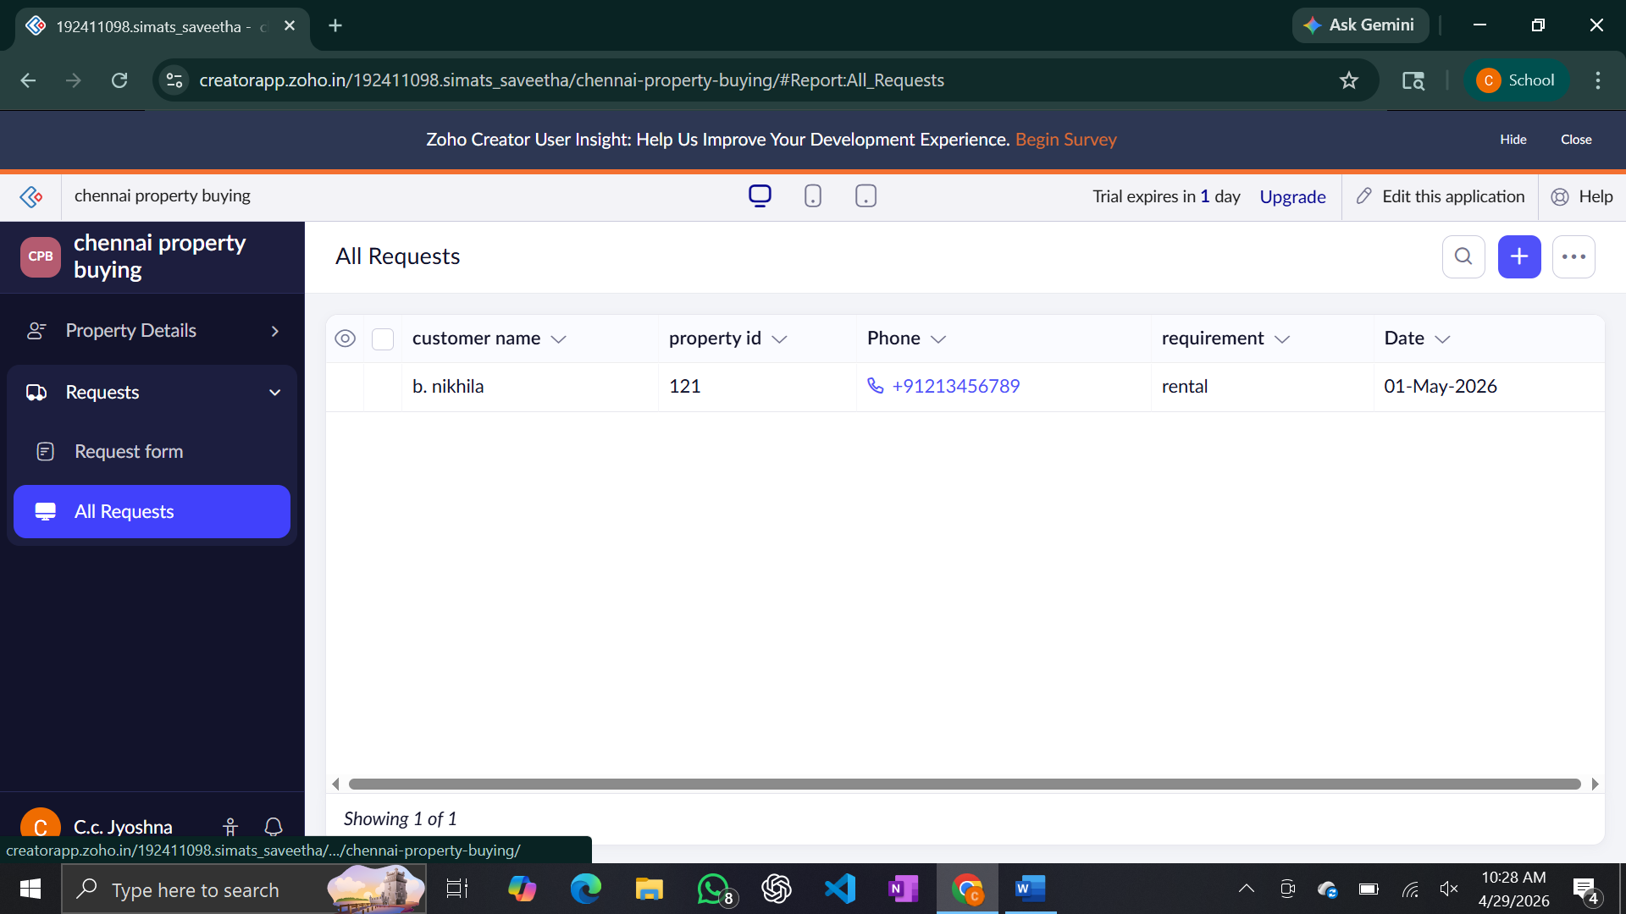
Result: A cloud-based property management system is created for Chennai real estate.
Exp 04:Car booking reservation system

Aim: To develop a cloud-based system for car booking and reservation.
Software Required
- Zoho Creator
- Web Browser
Procedure
- Create application in Zoho Creator
- Create Users form (Customer/Owner)
- Create Cars form (Car details)
- Add booking user field (lookup)
- Create booking report
- Publish application
Output :
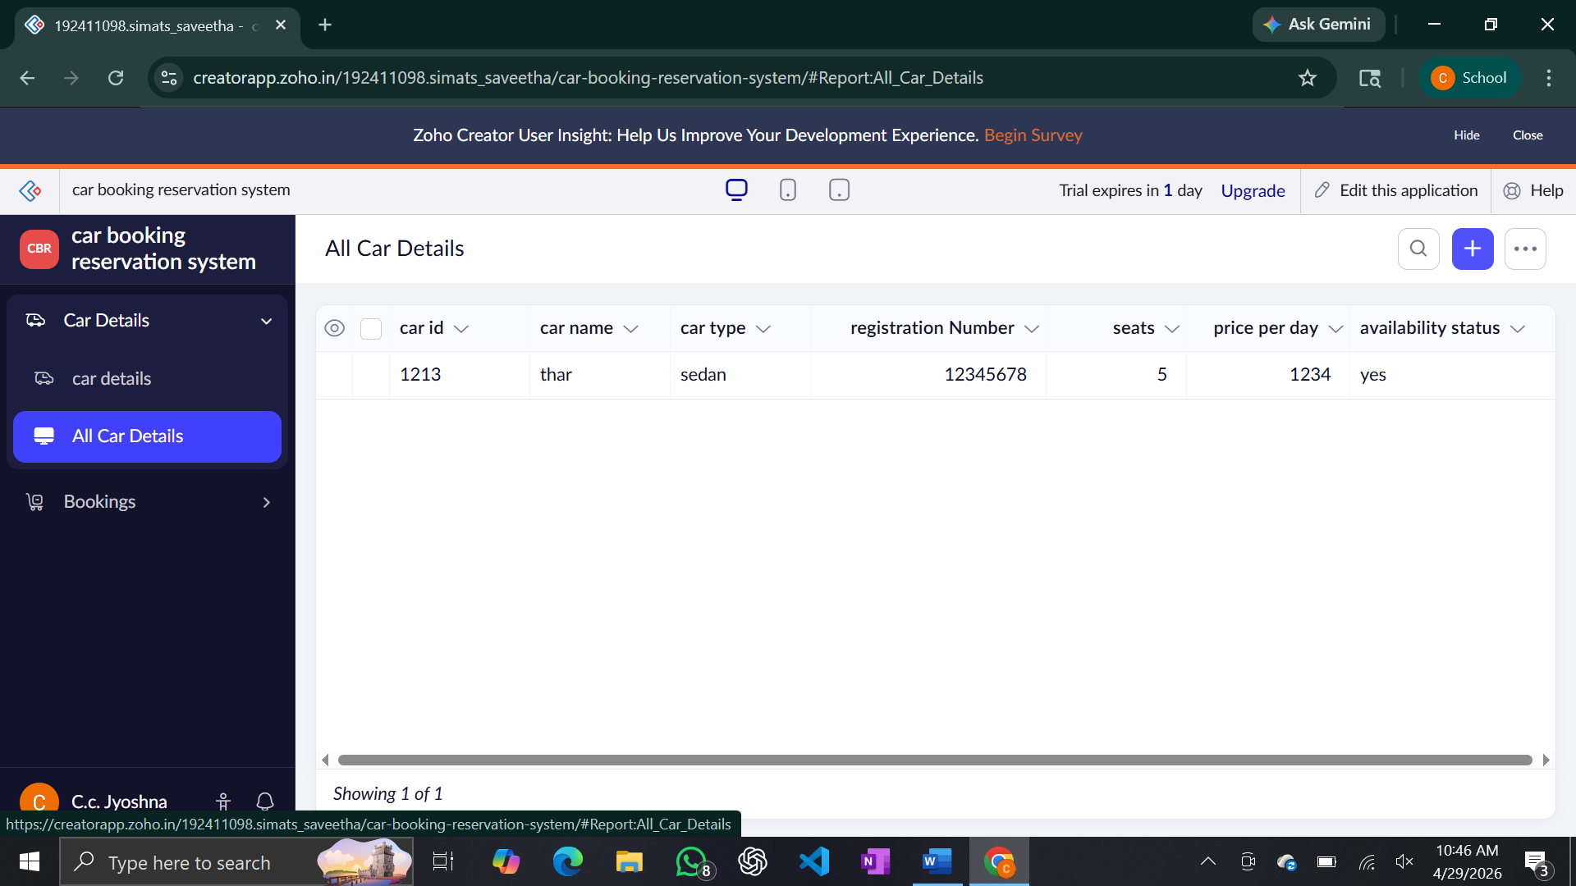
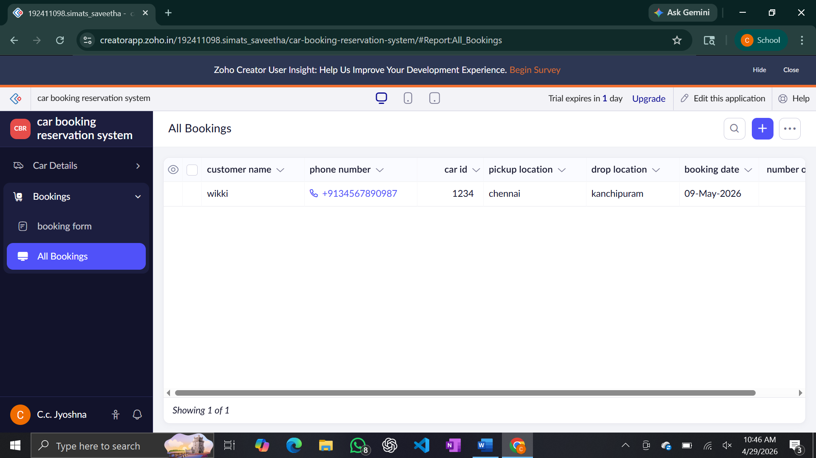
Result: A SaaS-based car booking system is developed for online reservations
Exp 05:Hospital Management System

Aim: To develop a cloud-based system to manage hospital patient records.
Software Required
- Zoho Creator
- Internet
Procedure
- Create application in Zoho Creator
- Create Users form (Patient details)
- Create Records form (Doctor/Patient data)
- Link patient with records using lookup
- Create report for patient details
- Publish application
Output :
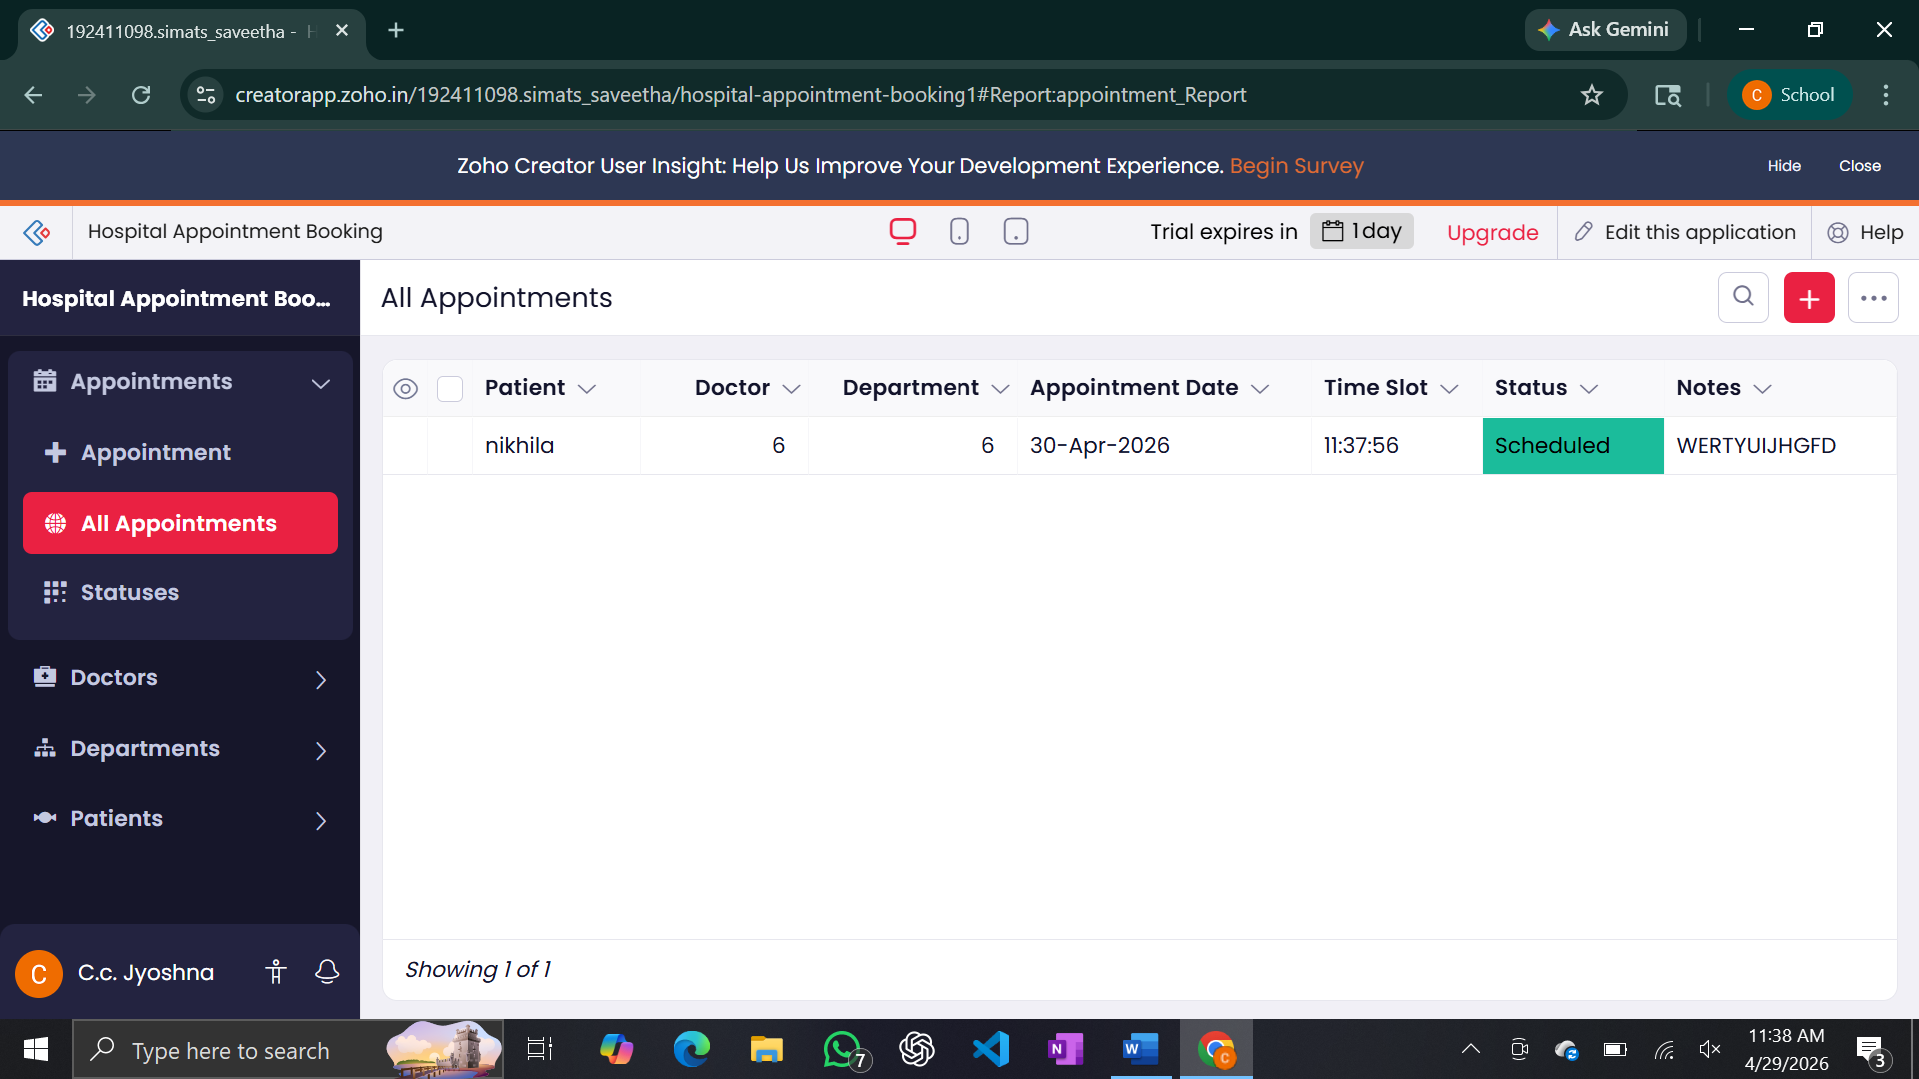
Result
A SaaS-based hospital management system is created to manage patient data efficiently.

Exp 06: Library Mangement System

Aim: To develop a cloud-based system for managing library books and reservations.
Software Required
- Zoho Creator
- Internet
Procedure
- Create application in Zoho Creator
- Create Users form (Student/Staff)
- Create Books form (Book details)
- Add reservation field (lookup)
- Create book report
- Publish application
Output:
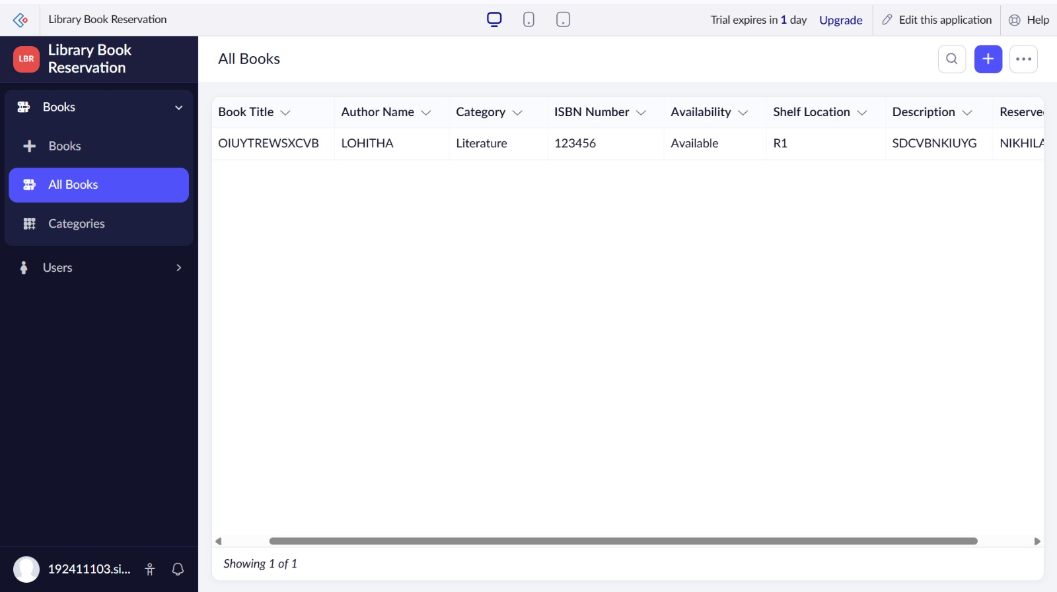
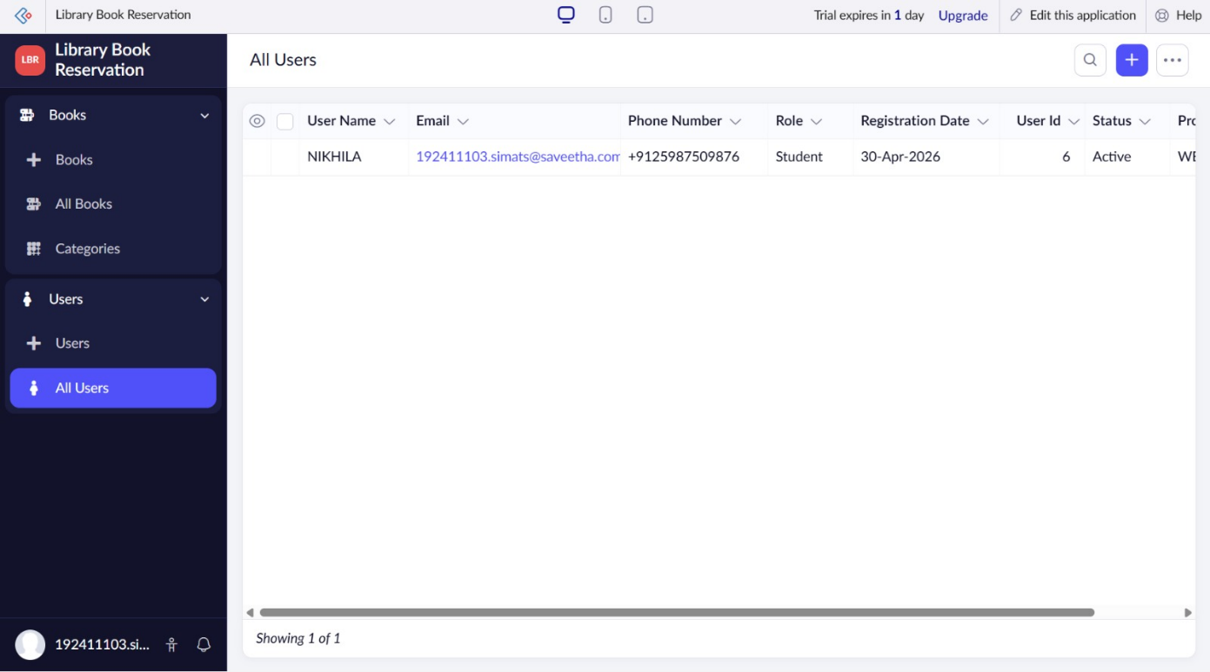
Result: A SaaS-based library management system is created for managing books and reservations.

